**T.Y .BTech (Electronics) – Image Processing**

**Expt No -4 : Image Histrogram and smoothing**

**Problem Statement** –

1. Write a program to read an image, plot its histogram then do histogram equalization. Comment about the result
2. Implement various Smoothing spatial filter.

* **Objective:** To analyze the effect of different intensity image enhancement on image.
* **Tools Required:** MATLAB
* **Theory:** *Brief describe in short*
* **Specify the syntax used in MATLAB for following operation**.

(a) Histogram

(b) Histogram equalization

(c) Smoothing spatial filter

.

*Hint : you tube link shared on classroom*

* **Conclusion**:
* **Discussion** –

1. ***Program 1:*** Write a program to read an image, plot its histogram then do histogram equalization.

clear all;

clc;

% image histogram equalization

% Read color image

A = imread('cameraman.tif');

B= histeq(A);

subplot(2,2,1),imshow(A);title('Original Image');

subplot(2,2,2),imhist(A);title('Original Image histrogram');

subplot(2,2,3),imshow(B);title('histrogram Image');

subplot(2,2,4),imhist(B);title('histrogram Image histrogram');

***Results:***

***Output***

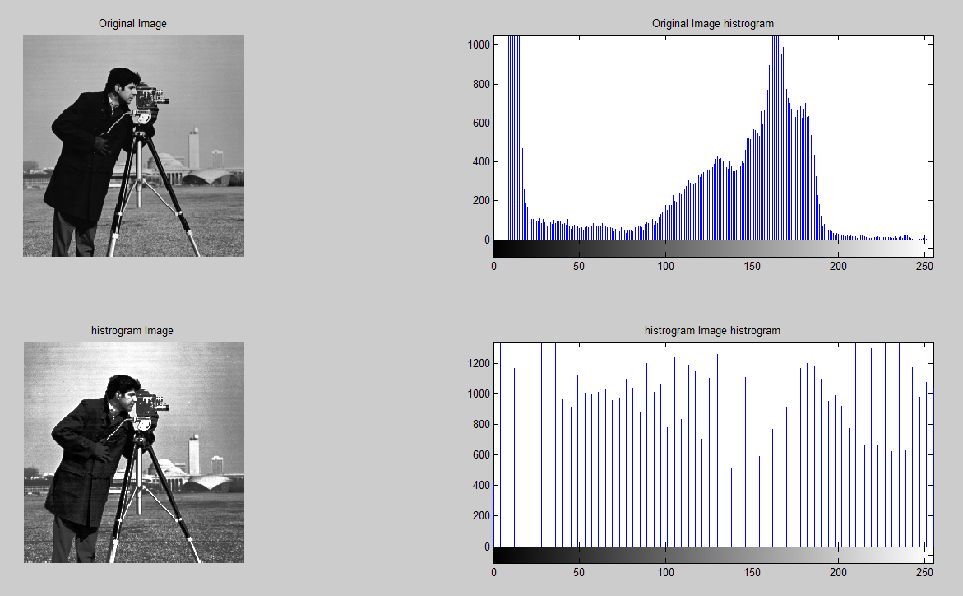

1. ***Program 2:*** Write a program to implement various Smoothing spatial filter

clear all;

clc;

% Read input image

I = imread('pout.tif');

% Addition of noise to the input image

B = imnoise(I, 'salt & pepper');

%kernal of avering filter

h1=1/9*ones(3,3);

h2=1/25*ones(5,5);

% application of filter

B1=conv2(B,h1,'same');

B2=conv2(B,h2,'same');

% display of input and output image

subplot(2,2,1),imshow(I);title('Original Image');

subplot(2,2,2),imshow(B);title('noisy image');

subplot(2,2,3),imshow(uint8(B1));title('filter noisy Image');

subplot(2,2,4),imshow(uint8(B2));title('filter image');

***Results:***

***Output***

